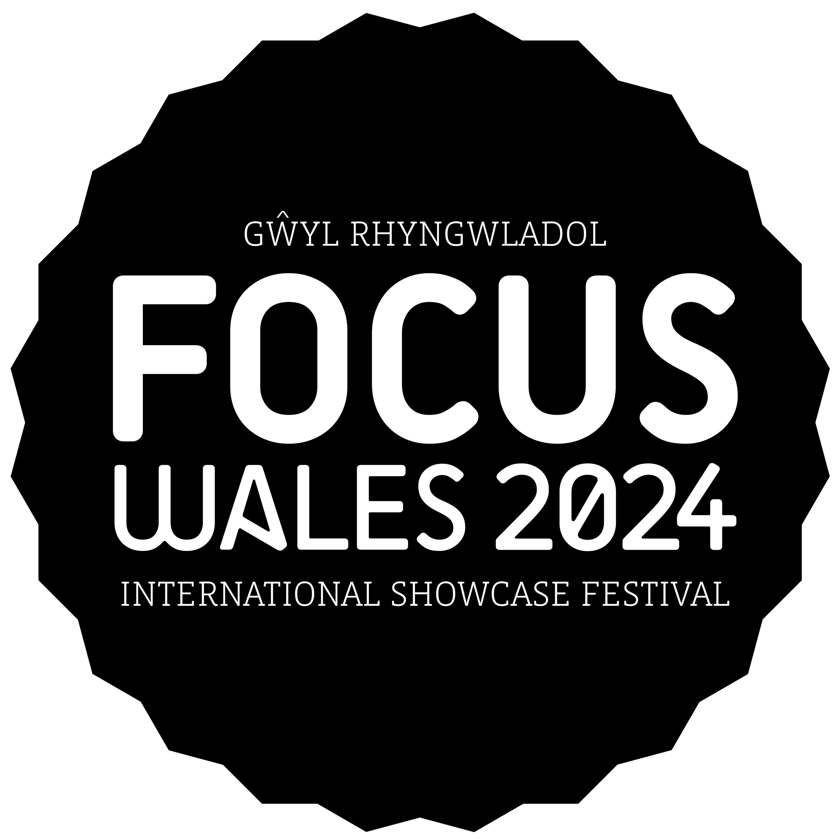

**Access Requirement Form**

**Part 1: Application Process**

**This is the process by which bookable access facilities can be requested:**

* Purchase a ticket
* Obtain a ticket reference number
* Send us your completed Access Requirement Form (only valid with a ticket reference number) and any supporting evidence.
* We will endeavour to respond within 5 working days to confirm your requests
* We will then send you a confirmation email, and instructions on what to do next

**Submitting your form**

Email your completed from to: sarah@focuswales.com

Or, post your completed form to: FOCUS Wales, 15 Yorke Street, Wrexham LL15 1UD

If you have any questions about this process, contact us via: [sarah@focuswales.com](mailto:sarah@focuswales.com) or call 01978 345230

**Submitting supporting documents**

When submitting documents to support your application, we ask that if possible you:

* Scan/take a photo of evidence and attach it with your form if emailing
* Photocopy evidence and clip it to a printed form if posting

This helps to speed up the process considerably.

Please feel free to black-out any information that relates to amount of benefit paid or health conditions etc. that might be on any documents submitted.

**Part 2: Personal Details**

Ticket Reference Number:

Type of ticket purchased e.g. Friday Day Pass, Full Weekend Pass:

Name:

Address:

Tel:

Email:

**Part 3. Access Provision Request**

**Please check the box next to the access provision you would like to book.**

A free ticket for a personal assistant (2:1 ticket)

**Part 4. Information / Evidence**

Evidence is required to gain a 2:1 ticket

**1. Automatic Eligibility**

A photocopy / scan of one of the following documents (dated within the past 12 months if DLA or Attendance Allowance) makes you automatically eligible for any of the above access facilities. Please check the box next to the evidence you wish to submit:

Front page of DLA letter (no specific rate required)

Front page of Attendance Allowance letter (no specific rate required)

Front page of War Disablement Pension

Evidence that registered severely sight impaired (blind)

Recognised Assistance Dog ID card

[CredAbility Access Card](http://www.accesscard.org.uk/) (+1 requirement stated)

None of the above (see below)

**2. Statement (with option to send alternative evidence)**

We recognise that the evidence above is not definitive. If you do not have any of the above evidence but wish to apply for the above access facilities, use the box below to state why you require them:

You are welcome to post or email copies of any additional evidence that supports your application if you have any, or contact us to discuss your application. Your application will be judged on a case-by-case basis.

If you wish to submit any additional evidence to support your statement, please list it in the box below and attach it with your form:

**Part 5. Access to the performance**

If you have alternative access requirements for experiencing the performance that are not covered by a 2:1 ticket, please describe them below, and we shall make every effort to make a reasonable adjustment to meet your needs if possible.

**Part 6. Access database**

Please note that all collected data will automatically be deleted in 1 year of submission if you do not request access facilities in this time. We will not share your data with any third party organisations.